Unity Team
Matteo Dell’Oro, Alfio Giuliano Faro, Gabriel Logronio

PROTOTYPE SCENOGRAPHY DOCUMENT

Purpose | Document containing setting and script of the prototype level
Creation date | 22-11-2017
Current owner | Alfio Giuliano Faro
Last modification | 24-11-2017

Revision History
Who | When | What
Faro | 22-11-2017 | Created this document
Faro | 23-11-2017 | Added Setting
Faro | 24-11-2017 | Added Script

Setting

In the beginning of the level the group lands a bit far from the factory and the landing point surrounded by a desert, without anyone around. The air is dry and dusty. The zone is covered with poor vegetation, only weeds and brambles grown here and there. In the courtryard of the houses the grass is totally dry and yellowed, the ground’s color is a bright tone of brown. The landscape is desolate and in ruins. The sun is setting down.
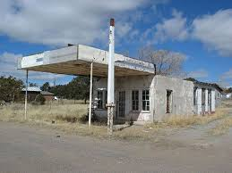
(A gas station in ruin near the landing point)

After looking around for a little bit a small town can be noticed. Houses and streets are just ruins of what they used to be. From the town you can see a huge light and hear noises coming from the factory, just outside. No one lives there.
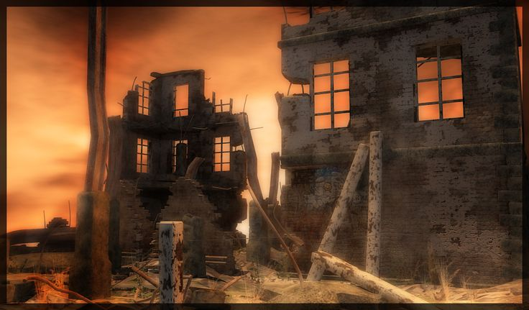
(The view of the factory from the town)

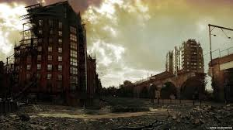

(A view of the city, with buildings in ruins and a bridge)
The factory has a huge courtryard with some buildings, tanks, tubes, drills, bulldozers and quite a lot of materials used in the works. In the middle of the factory there’s a big tower.
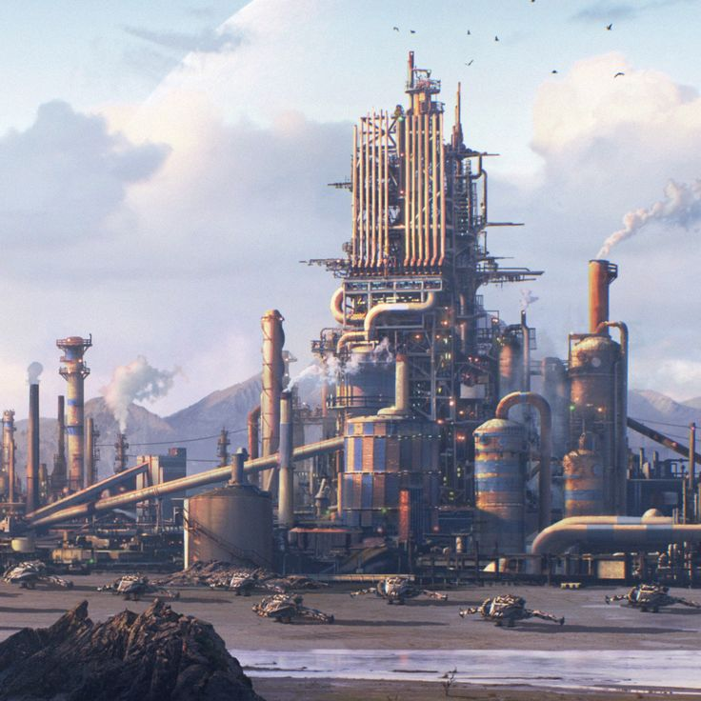
(A view of the factory from afar)

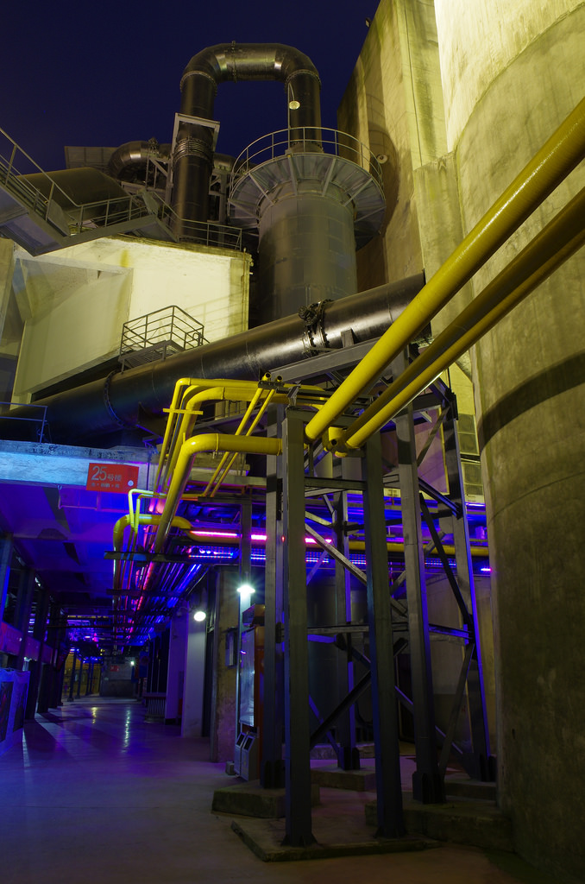
(A view from inside the factory, we can see tanks and tubes)

The corridors are wet and long, with some artificial neon on the roof. Everything is made out of iron and metal. The tubes run attached to the walls, and they change their paths only near a door. Many stairs and an elevator lead to the different floors, with a big door consisting in the entrance to the main hall. The main hall contains the production line, where a lot of cyberman and sontaran's armors are being assembled. The predominant colour are grey and black, with the tubes looking heavy and rusted. A strong smell of chemical agents is in the air, inside the rooms and the corridors. Sometimes cold air can be felt coming from outside through the cracks. The corridors are patrolled by some cybermen. The atmosphere is oppressive, the ambient is claustrophobic and the presence of cybermen make you feel haunted.

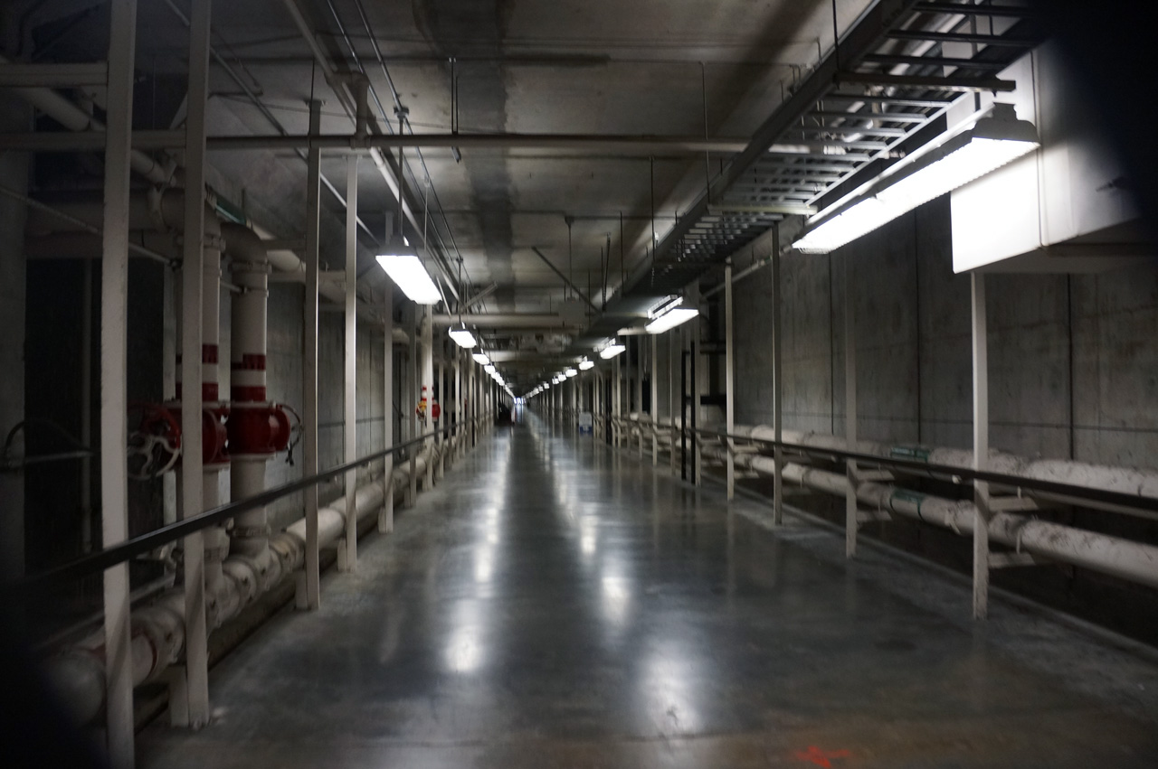
(An example of a corridor)

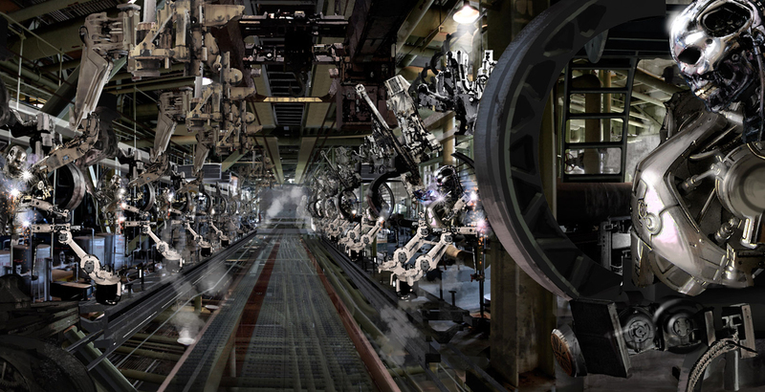
(A view of the main hall where the factory line of production is)

Inside a room you can find monitors, tables and some papers written by the scientists that work there. In another part of the factory you can find the dorms where the human workers are kept.

Some rooms are laboratories, where scientists work under the supervision of some cybermen.

Upstairs, on the top floor, you can find the control room, where Strax is located. This is a huge room with one big window in front of the entrance door, where you can look the landscape of the factory and the places around it. Just under the window there is a big desk with computers, monitors, buttons, and a chair where Strax is seat. The room is very bright, different from all the other rooms in the factory, the walls are white and the floor is polished and clean, made out of a bright and perfect grey material. The air inside is fresh and clean, not even outside the factory it is this pure. This room transmits a sensation of calmness, but you feel the electricity in the air, like that “calm before the storm”.

Script

"Finally we have landed" Jack says after that the Tardis stopped. The group gets out the Tardis. "Where are we?" Jenny asks while looking around. "I think we’re still on Earth" answered Clara, "Look there, it seems like a gas station or a little shop". "Let’s hope we find other beautiful travelling companions here" tells Jack, looking at Ashildr. The girl rolls her eyes and snorts at Jack's sentence.

The group heads to the gas station, where inside a part of the roof is broken with the sun coming in. In the sky the last daylight is leaving early in the evening. No one is inside, but products are still on the shelves. "Looks like they ran away in a hurry" tells Jack while checking around with his rifle ready to fire. "It's strange" Clara picks up a bowl containing some beans, now dented and moldy, "they fled so quickly that they didn't even take away all this food!". Jack looked Clara and says "I love it when you analyze! Now I think we better leave and look for a place to rest"

While walking around Clara asks Alros why he is so silent. "I'm worried about my brother, I hope he’s ok. I need to find him". "Don't worry, I'm sure he is fine!".

The party follows the street until they reach a little town, now in ruins. The buildings were destroyed due to neglect and bad weather over the many years and dust cover the roads. Here and there some plants can be spotted, but they’re just trunks without life. While they look around the city hoping to find something interesting, a cyberman attacks them. After the battle is over they examine the body and find a radio signal heading to a nearby place. After a few minutes of exploration towards the direction of the radio signal Jenny screams from inside a building :"Hey! Look at that!" pointing at a bright light in the sky. From a window the company can see a huge complex of buildings, tanks, and a big tower in the center. "I think that's a factory" says Alros, "I'm sure that the cyberman has to come from there!". "It's possible" tells Ashildr, looking at the complex. "We must find a way to get in!" the voice of Clara is firm and secure, "I'm sure that the answers we’re looking for are in there!".

They follow the main street but all the cyborgs are alerted by the defeat of their fellow in the town. "There is too much surveillance, it's impossibile to get in from the front door without fighting, we must find another way to get in!" Clara says "Look, there is a little river right there, maybe we can use it to get to the sewers of the factory".

Clara was right, not too far away there is a gutter from where the water comes out in the river. "Maybe we should use it to get in" proposed Ashildr. "Ok I’ll watch your back...your back...ehm sorry I look back" says Jack, and immediately Clara taps him on the neck, while Alros is laughing at that scene.

"It's strange: this water does not smell like you would expect, actually it does not smell at all!" says Alros looking around in the dark tunnels, "It's dirty, yes, but there are no 'dirty gifts', if you know what I mean. I don't think it's the sewers, I think this water is just used to do something in the factory, maybe some processing". "I agree " replicates Me.

Finally they get in a huge empty room where the water comes in and gets out through the channel. The stairs inside are located next to a wall of the room. "Ok from now on we must be as silent as possibile" orders Jack, and the group nods together. Our heroes leave the channel just to find a big corridor.

Five meters on the rigt they find a door, inside there are some tables with scientific stuff, monitors, and two cybermen. Our friends try to make a sneak attack and they manage to knock out the enemies without triggering the alarm.

"Ok, let's look for any clue" Clara says. In this room, in one monitor a note writed by someone "This is the last time that I’m covering you, if they find out what you are thinking you are getting both of us killed! You know it is forbidden! Leave your desire for vengeance and try to live as long as you can Mikey! I love you, Laura". After reading the message the group continues to explore the factory.

They find a big door with a big sign "Production line". Clara tries to open the door but it's locked.

The group explores another corridor which leads towards an elevator. Jenny tries to activate it. "Guys i think that this goes up, maybe we can find something there, but we need a pass". The group explores another room of the complex where they find two cybermen that are controlling the work of few scientists. The group does another sneak attack and, after the battle, they succeed in defeting the cyborgs.

One of the scientist approches Clara: "Many, many thanks! We’re glad for the help! They kept us here for so long".
"Who are you?" Clara asks. "I'm Michael Begance, the lead scientist in this lab. They have kept us here to produce cybermen and design armors, I don't know what the purpose of those machines is, but they treated us as slaves and..." his voice breaks as the man starts to cry "and they killed my wife, right in front of my eyes".
Alros tries to cheer up the man and asks "Do people call you Mikey around here?". The man looked like hit by a fist: "It’s just Laura who used to call me that way. " Alros takes out the note and gives it to the doctor. The man starts to cry again "Oh Laura what have I done?". Clara starts to talk : "We want to put an end to this, we don’t want anyone to suffer anymore. But in order to do that, you need to help us". The man rises his head up, wipes the tears and says: "On the top floor of the tower you can find the commander of this place, he has control over all the cybermen, defeat him and you will free us all. Take this, it's my badge. You can enter the tower but it won’t let you go until the last floor; in order to do that you have to go to the office room, insert my card in the terminal and hack it increasing your permissions. If you succed you will be able to reach the elevator and face the commander". Clara hugs the man, and with the group heads to the room in the tower where they the terminal is located.

Inside this room there are other two cybermen guards, they defeat them and after solving a puzzle they get the permission.

They come back to the elevator and go to the commander's room. The door is open as if he is expecting them. "Good evening my friends" says the commander as soon as they enter the space "I'm Strax, and I welcome you to my kingdom. Unfortunately, you will not live long enough to enjoy it". The room is well-lighted, very big with a huge window to admire the landscape of the factory. He is standing between the window and his desk, looking outside and with his back to the gourp.

"You have to stop all of this!" cried Clara, "Enough people suffered already! Cut it off now or we will!"

"I dare you to try!" answered Strax, engaging the group in a fight.

